HIMALAYAN INITIATIVES CHARITY TREK OCTOBER 2019

October 12th – October 28th
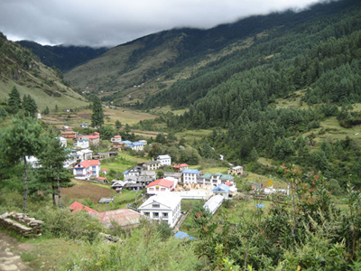
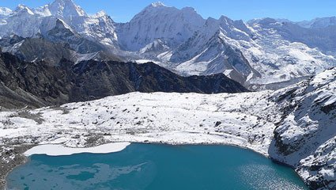
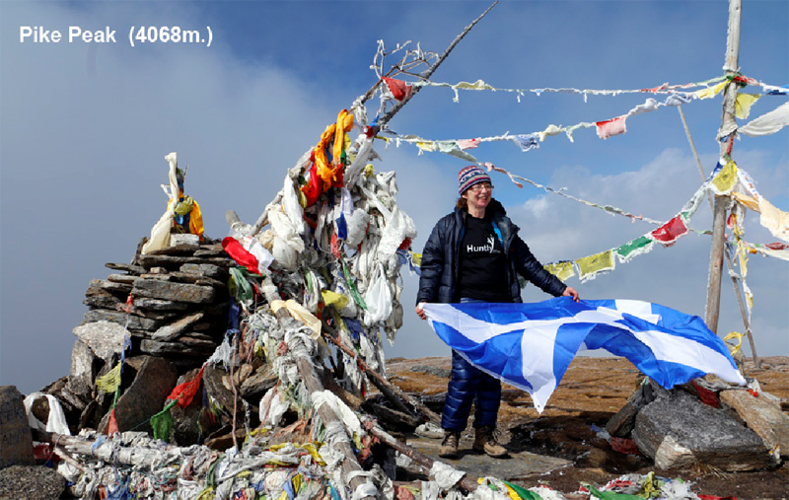
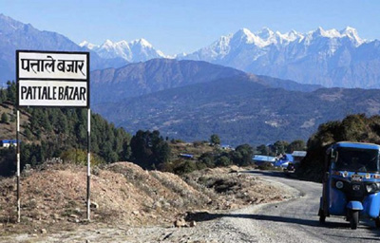

Introduction by Kumar Karki of CBSD and Tailored Treks

We welcome you on this special charity trek to explore the beauties of Nepal while also supporting communities in need.

The trek is part of the social charity work of Nepal NGO Community Building for Sustainable Development (CBSD). CBSD works in partnership with Scottish charity Himalayan Initiatives to promote positive change in one of the most stunningly beautiful yet most impoverished areas in the lower Everest region of eastern Nepal. Our work is focussed on the villages of Simigaon (Dolakha district), Nele, Jhareni and Mammerku (Solu Khumbu district). This trek is delivered by trekking company Tailored Treks & Expeditions, which works with CBSD and local communities to develop tourism in a way that brings benefits directly to the local people.

CBSD was established by supporters and young people from the region. Members of CBSD & Tailored Treks have a wealth of trekking experience and local knowledge, and are committed to giving something back to the community.

CBSD activities include supporting:
a) The distribution of modern Metal Stoves with chimneys,
b) Schools with books, furniture, building construction & repair,
c) Health posts with medicine, staff training, building construction and maintenance,
d) Agricultural support activities.
The overall aim is to improve education, health, income generation and general basic services in order to improve the quality of life in the region.

During the trek, we will visit our project areas, interact with the community, participate in community events, and share our ideas and suggestions for improving basic services in the region.

We welcome all those who are open to our aim of social service and who are prepared to face the challenges associated with bringing change in areas of need. Due to advancements in communication and technology, the interdependence of one area of the world with others is becoming ever more apparent. Consequently, we feel that interaction between communities, sharing of resources and knowledge is increasingly important to bring about harmony and balance in our world today. Through small initiatives such as this trek, we aim to contribute towards this goal.
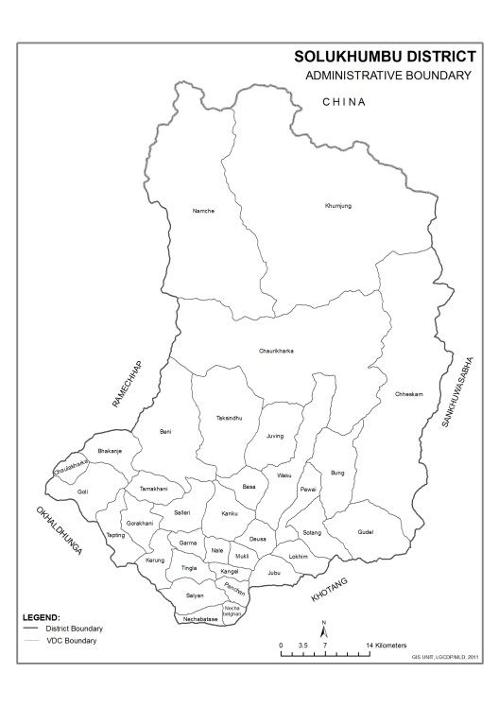
Jhareni School Project Area
Nele Project Area
Pikey Peak
Lukla/Namche Bazaar Area

Dudhkunda

Himalayan Initiatives Charity Trek October 2019
Kathmandu-Pattale-Pikey Peak-Junbesi-Dudhkunda-Nele-KTM

Special features:
- Discover the sights of Kathmandu
- Enjoy trekking through changing eco zones and mountain vistas
- Marvel at the views of the Himalayan Giants (Everest, Numbur, Kanchenjunga, Lhotse etc)
- Discover village life away from the main tourist trails
- Meet with local Sherpa people and learn about their unique culture
- Visit traditional Buddhist monasteries
- Meet with local people in Nele and learn about the community projects
- Experience a traditional Shamanic “Chinta”
---------------------------------------------------------------------------------------------------------------

PROGRAM ITINERARY

Day 1. Sat 12 October
Arrive in Kathmandu. CBSD/Tailored Treks will welcome you at the airport and transfer you to Ambassador Garden Home Hotel, Thamel. Shower, rest and relax. Those with lots of energy can explore Thamel (tourist quarter). Evening group meeting at approximately 6pm.
.
Day 2. Sun 13 October
City sight-seeing tour (optional) or your chance to rest before the trek begins. There are many shops nearby the hotel,most are open into the evening, handy for those last minute essentials, extra trekking gear, chocolate/snacks etc.

Day 3. Mon 14 October
Drive from Kathmandu to Pattale Danda 8 – 9 hrs.
Overnight at Teahouse or Camp.

Day 4. Tue 15 October
Trek to Jhapre, 6-7 Hrs. Overnight at lodge.
Jhapre is a small Sherpa village with a beautiful Buddhist monastery (gompa) which hopefully we will be able to visit.

Day 5. Wed 16 October
Trek from Jhapre to Pikey Base Camp. Overnight camp.
It is a long gradual picturesque climb from Jhapre towards Pikey– through woodland, rhododendron forest and heathland.

Day 6. Thu 17 October
Early morning ascent of Pikey Peak, descend to Jasmane Bhanjyang then onward to Jumbesi. 7-8hrs. Overnight lodge or camp
Pikey Peak at 4068m is one of the highest “hills” in Solu. The name Pikey is derived from the name of a Sherpa Clan deity. During the month of July the locals hold celebrations to worship their clan god.
Weather permitting there will great views of Numbur Chuli and the Everest region including Mt Everest, Makalu, Pumori, Nuptse, Lhotse.

Day 7. Fri 18 October
Trek from Jumbesi to a suitable campsite visiting Thupten Choling monastery en route. Thupten Choling monastery, about 2 hrs trek from Jumbesi, is one of the largest Buddhist monasteries in Nepal. It was founded in the 1960’s by Thulsuk Rinpoche and is home to both monks and nuns.

Day 8. Sat. 19 October
Trek to Sasharbeni (3835m), high yak pastureland - overnight camp.

Day 9. Sun. 20 October
Trek Sasharbeni to Dudh Kund and back - overnight camp.
Dudh Kunda (4560m) is a small, holy lake surrounded by a perfect landscape that will touch your heart. Dudh Kunda, which literally translates as “Milky Lake”, is situated at the base of Numbur Himal (6,958m). The lake is reputed to give spiritual power to local shamans. Hundreds of shamans visit the lake every August at full moon.
There are great views of the Khumbu range including Mt Everest (8848m), Makalu (8475m) Kanchenjunga (8598m), Cho Oyu (8188m), Lhotse (8414m), Thamserku (6608m), Numbur (6656m), Khatang (6853m), and Karilung (6511m).

Day 10. Mon. 21 October
Trek Saharsbeni to Taksindu or Ringmu. Lodge or camp.

Day 11. Tue 22 October
Trek Ringmu to Phaplu. Overnight in Everest Lodge

Day 12. Wed 23 October
Trek Phaplu to Nele via Chyalsa Overnight at Mum’s homestay.
Chyalsa Tibetan Refugee Camp was established in the 1960s. Refugees fleeing the Chinese were given the opportunity to learn carpet weaving, supported by the Swiss Government. At its height 20000 refugees lived here, now only a handful of families remain but there are an ever-increasing number of beautiful monasteries funded by those who once took sanctuary in this special place.

Day 13-14. Thurs/Fri 24-25 October Free days to explore Nele. meet the local community and learn about the work of Himalayan Initiatives and CBSD. There will be an opportunity to participate in an evening shamanic “chinta”.

Day 15. Sat 26 October
Jeep from Nele to Dhulikhel 8-9hrs
Time permitting we will stop in Salleri to experience the local Saturday market

Day 16. Sun 27 October
Jeep to Kathmandu via Bhaktapur for sightseeing.
Overnight Ambassador Garden Home.
Bhaktapur, situated 20km east of Kathmandu is a UNESCO World Heritage Site.
Many of its temples and palaces were badly damaged in the 2015 earthquake, but repairs are on going and it’s a fascinating place to visit for its architecture, history and Newari culture. It is home to many types of artisan and a good place to pick up some craftwork to bring home.
Tonight is our last night together as a group so lets make it a good one with a Farewell dinner (optional, own expense)

Day 17. Mon 28 October
Depart Tailored Treks will arrange your airport transfer.

Cost: | Remarks:
GBP 1380 : per person on twin sharing basis  GBP 1575 : per person inc. single person supplement  £200 deposit payable to Himalayan Initiatives to secure your place.  Balance payable in cash directly to Tailored Treks after arrival in KTM.  (Payment by international bank transfer is possible and incurs an additional 13% VAT) | Ambassador Garden Home Hotel or similar rank.  All prices are calculated at current exchange rates (approx. 144NPR to GBP) In the unlikely event that the rate drops to below 125NPR in October a small surcharge may be requested.

Trek cost includes:

- Hotel Kathmandu/Dhulikhel 4 night only (3 nights KTM & 1 night Dhulikhel) B&B only, twin sharing basis
- Food & Accommodation during trek
- Wages for Guide & Porters
- Permit fees if applicable.
- Airport pickup/drop
- Kathmandu-Pattale by Jeep
- Nele-Dhulikhel by Jeep
- Dhulikhel-Kathmandu by Car/Jeep
- Kathmandu valley sightseeing
- Government Tax
- Staff insurance
- All Local Transportation
- Office service charge
Costs not included:

- Extra hotel nights in Kathmandu
- Personal expenses (Tips, donations, meals in Dhulikhel and Kathmandu, bar bill, souvenirs etc. Please allow approx. £100 for staff tips)
- Helicopter Rescue (in case of accident)

We hope that participants will each be happy to raise at least £300 for
Himalayan Initiatives (Scottish Charity SC044266) through fundraising or sponsorship to support CBSD’s project work in the villages (including villages you may be visiting-so you will be able to report back first hand how the money is being used!).
Join us for the Aberdeen Kiltwalk Sunday 2nd June and any money you raise is given a 40% uplift making it easier to reach that £300 target
Alternatively you will be given details of our online trek fundraising platform and you can set up your own linked fundraiser page on the platform.
THANK YOU FOR YOUR SUPPORT!
www.himalayaninitiatives.co.uk Reg. address: Cluny Victoria Rd Huntly AB54 8AH

PLEASE NOTE:
This itinerary is designed to be flexible and may be subject to change due to circumstances at the time.

This trek is strenuous and requires you to be able to walk carrying a daypack for up to 8-9 hours to a maximum altitude of 4561m. A reasonable level of physical fitness is important so we advise doing some preparatory hillwalking in the months before.
Please ensure that your travel insurance covers you for trekking at this altitude and for helicopter rescue (in the unlikely event of this being required.)
Tailored Treks will require a hard copy of your travel insurance prior to trek please.

For any enquiries or to reserve a place on this trek please email jane@himalayaninitiatives.co.uk

An Equipment List is provided below for your guidance

EQUIPMENT LIST FOR TREKKING

- Sleeping Bag 3 or 4 season (You can hire in Nepal)
- Silk liner
- Trekking Boots (Waterproof)
- Lightweight shoes
- Trekking Socks
- T-shirts
- Lightweight shirts
- Down Jacket (You can hire or buy cheaply in Nepal)
- Waterproof Jacket & Over trousers
- Trekking Trousers
- Underwear & base layers
- Woollen hat
- Sun Hat
- Sun Glasses
- Trekking Poles- optional
- Gloves
- Towel
- Sun cream
- Lip balm
- Water Bottle x 2
- Day back pack
- Biodegradable all-purpose soap
- Head Torch and spare torch
- Insect repellant
- First Aid kit including blister kit, plasters, paracetamol, aspirin (for altitude headache if not contra-indicated) loperamide for diarrhoea,
cinnarizine for nausea, cetirizine for itch/bites.
26.Means of water purification. Boiled water is supplied on trek – as a safeguard we recommend also using water purification tablets
(available in KTM) or another approved purification system eg. Steripen
27.Camera with extra battery - optional (Electricity is available on the way)
28. Altimeter, Binoculars, GPS unit etc.-optional
29. Reading materials, Notebook, Pens etc.- optional

